**Azure AI Document Intelligence**

[Document Intelligence documentation - Quickstarts, Tutorials, API Reference - Azure AI services | Microsoft Learn](https://learn.microsoft.com/en-us/azure/ai-services/document-intelligence/?view=doc-intel-3.1.0)

* Cloud-based Azure AI service
* Build intelligent document processing solutions
* key to improved operations, informed data-driven decisions, and enlightened innovation.

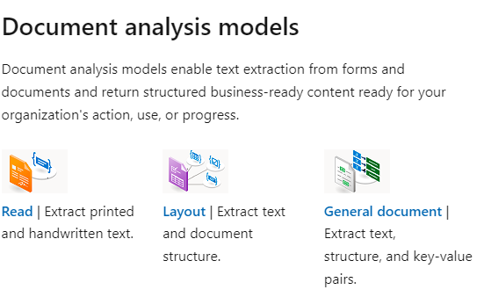

* Advanced machine learning
* Identify documents
* Detect & extract information from forms & documents
* Extract data in a structural JSON output

**Can Use**

* Document analysis models
* Pre-built / pre-trained models
* Trained standalone custom models
* Custom classification models for scenarios you need to identify the document type prior to invoking the extraction model.
* A classification model can be paired with a custom extraction model to analyse and extract fields from forms and documents specific to your business to create a document processing solution.

1. **Custom document model types**

* Custom extraction models
  + Custom neural model
  + Custom template model

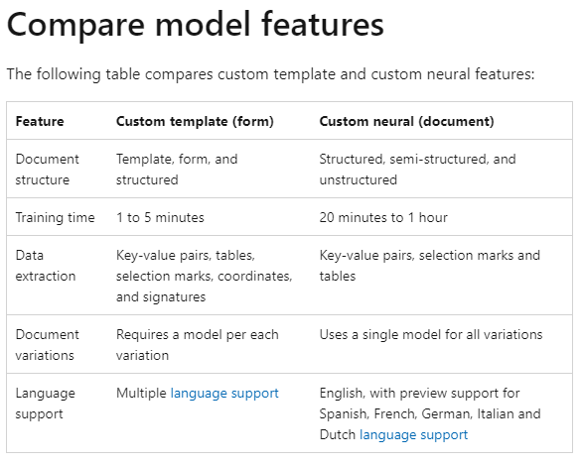

* Custom classification model (new scenario supported by Document Intelligence with the 2023-07-31 (v3.1 GA) API)

